Benin

## Respect for rule of law (ROL) data

The data set shows the data on the respect of the rule of law for the country.

## # A tibble: 19 x 5  
## country iso3c date ruleOfLaw ruleOfLawCategory4   
## <chr> <chr> <dbl> <dbl> <chr>   
## 1 Benin BEN 1996 0.0523 ROL moderately respected   
## 2 Benin BEN 1998 0.0418 ROL moderately respected   
## 3 Benin BEN 2000 -0.157 ROL moderately disrespected  
## 4 Benin BEN 2002 -0.229 ROL moderately disrespected  
## 5 Benin BEN 2003 -0.378 ROL moderately disrespected  
## 6 Benin BEN 2004 -0.510 ROL moderately disrespected  
## 7 Benin BEN 2005 -0.542 ROL moderately disrespected  
## 8 Benin BEN 2006 -0.534 ROL moderately disrespected  
## 9 Benin BEN 2007 -0.517 ROL moderately disrespected  
## 10 Benin BEN 2008 -0.534 ROL moderately disrespected  
## 11 Benin BEN 2009 -0.654 ROL moderately disrespected  
## 12 Benin BEN 2010 -0.673 ROL moderately disrespected  
## 13 Benin BEN 2011 -0.663 ROL moderately disrespected  
## 14 Benin BEN 2012 -0.586 ROL moderately disrespected  
## 15 Benin BEN 2013 -0.569 ROL moderately disrespected  
## 16 Benin BEN 2014 -0.488 ROL moderately disrespected  
## 17 Benin BEN 2015 -0.536 ROL moderately disrespected  
## 18 Benin BEN 2016 -0.608 ROL moderately disrespected  
## 19 Benin BEN 2017 -0.625 ROL moderately disrespected

## Respect for rule of law (ROL) trend

The plot shows the trend of the respect for the rule of law for the country.

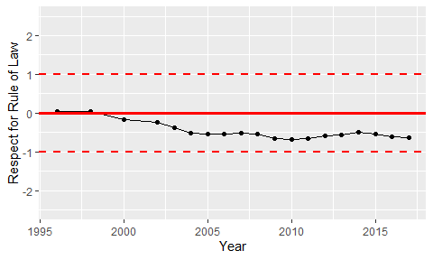

Trend of the Respect for the Rule of Law